

**FML IT**

**CIO Report**

**September 2023**

|  |  |
| --- | --- |
| Author: | Candice Govender |
| Date finalized: |  |
| Document version: | 0.1 |
| Document status: | Draft |
| Document file name: | FML IT CIO Report |

Contents

1. Executive Summary 3

2. Systems Uptime 3

3. IT Incident and Service Management 4

3.1 Incidents Resolution 4

3.2 Month on Month Incident Report 5

3.3 Incident Age Analysis 5

3.4 Incident and Service Management commentary 6

4. Transaction Stats 7

5. IT Infrastructure and Software Management 8

5.1 Unsupported Technology 8

5.2 Upgrade Roadmap 8

5.3 Batch Monitoring 9

6. Capacity View 10

6.1 Business Analysis 10

6.2 Development 10

6.3 Quality Assurance 10

7. FML PMO Overview 12

8. Business Delivery 17

8.1 Initiatives in Progress 17

8.2 Initiatives Deployed 17

8.3 Total Deployments per Classification 18

8.4 Sofico Service Desk 20

9. Quality Assurance 21

10. HR 22

11. IT Risk 23

12. Security 26

13. Finance 28

14. General 29

15. Distribution 30

# Executive Summary

[To be updated] The much-anticipated go-live of M3 took place in July over 2 weekends. The code deployment of enhancements and changes made after the Upgrade over the weekend 14- 17th July, followed by the RT46 Data Migration and verification over 21st – 24th July. As anticipated, we were in high-care and the programme carefully tracked and prioritized urgent issues and there speedy resolution thereof. We will be in high-care till September. Production Incidents which had been worked on, and had been on hold due to the M3 freeze, had been deployed and emphasis is now on the Sofico Mitigation.

# Systems Uptime

* 1. Systems Uptime

Overall, we had an average uptime of 99.76%

For the Month of September, FML experienced one severity one outage (FNB Reportable), and three severity two outages (these outages are DR reportable), and one severity three outage (it must be noted that the severity three outage was not unavailable but intermittently slow).

**Figure 4: Systems Uptime – WesBank Applications (Data labels reflected where uptime less than 100%)**

**Figure 5: Systems Uptime – FNB/Vendor Applications (Data labels reflected where uptime less than 100%)**

**Figure 6: Systems Uptime – Reporting Applications (Data labels reflected where uptime less than 100%)**

**Figure 7: Systems Uptime – E-Business Suite (Data labels reflected where uptime less than 100%)**

# IT Incident and Service Management

## Incidents Resolution

| **Date** | **Incident** | **Business Impact** | **Root Cause** | **Remediation** | **Preventative Measures** | **Incident Classification/Duration** |
| --- | --- | --- | --- | --- | --- | --- |
| EMAILS | | | | | | |
| 07/09/2023 | **INC6060414 – Emails slow responses** currently Impacting on,FAIM**,** Correspondence Queue and Multimedia  from **07h00** to **11h42** | This resulted in statements being delayed on FAIM, and no work being received into the SPIFF and CIC Queues/Workgroups, when the service restored business SLAs would have been impacted for the duration of the outage | The delays were caused by a flood of emails from home loans' dev/test servers | i&SS Data Centre Exchange support blocked the IP address that was found to be causing delays, which helped to reduce the mail queues.  Home Loans: Unfortunately, Home Loans has not responded to requests from i&SS Data Centre Exchange support | The i&SS Data Centre Exchange support cannot prevent a mail flood on their side if the sender is a trusted internal server. However, they have monitoring systems in place to identify top senders, which is how they identified the sender in this case.  The preventative actions have to be taken on the sender's side, which in this case is Home Loans' support for their servers.  The servers have been blocked and cannot be re-added until feedback regarding preventative actions has been provided by Home Loans. | P2 high  Nr of incidents = 1  All incidents closed.  Cumulative duration of minutes 4 hours 42 minutes  FNB/DR reportable outage |
| 21/09/2023 | **INC6143889 – Microsoft Patch** errors Impacting Emails between **08h00** to**16h00** | This resulted in Timeouts within CIC Queues/Workgroups, when the service restored business SLAs would have been impacted for the duration of the outage, Impacting on Motor, Corp/ FML and JV partners | The i&SS teams were investigating with the Vendor, the service wasn’t unavailable mails were slow and causing intermittent flooding when it resumed | Vendor suggested I&SS to roll back that security patch | None provided | P3 high  Nr of incidents = 1  All incidents closed.  Service slow  FNB reportable outage |
| BI PORTAL | | | | | | |
| 07/09/2023 | **INC6059318 – BI Portal** missed SLA as a result of a long running Job**,** from **07h00** to **13h56** | This resulted in all business areas not able to open any daily reports within the BI portal instance | One of the database links used to connect to the EBS database was experiencing high waiting times. This delayed the extraction of data for the BI database tables which ultimately led to a delay in starting up the BI portal. | The Oracle DBAs were engaged and killed the session using the DB link because it was causing issues. The Oracle DBA team also updated the table's statistics on the source table, resulting in improved index usage and subsequently, improved waiting time for the impacted DB link. | No preventative measures were defined. The jobs that utilized the DB link were monitored during the subsequent batch runs for improvement, and they showed better performance. | P2 high  Nr of incidents = 1  All incidents closed.  Cumulative duration of 6 hours 56minutes    WB/DR reportable outage |
| TELKOM | | | | | | |
| 08/09/2023 | **INC6064941 –**  **BCX TElKOM PRI** errors impacting on WesBank on both number ranges **623** and **649** not available, from **07h00 to 10h00** | This resulted in staff being unable to receive calls via 0861, 011632 and 011649 numbers.  Impacting on WesBank and VWFS | BCX [Business Connexion Group] confirmed that the interruptions were a result of the core WAN infrastructure failure at the Openserve New Doornfontein data center. | In order to restore services at 09:50, BCX offered a solution and verified that SIP traffic had been effectively re-routed on their end.  The affected business units' inbound and outbound traffic were simultaneously redirected by WesBank voice support to manually point 0861 numbers to a FNB SIP [Session Initiation Protocol] as a workaround. | BCX [Business Connexion Group - Vendor] did not release information pertaining to preventative measures. To facilitate further tracking for true root cause and preventative measures, an I&SS problem management ticket has been created. | P2 high  Nr of incidents = 2  All incidents closed.  Cumulative duration of 3 hours  FNB reportable outage |
| NETWORKS | | | | | | |
| 19/09/2023 | **INC6129285 – Multiple** services impacted due to a Network outage from 20h05 up to 22h30 | No Business impact outage happened after business hours | i&SS Networks Data Centre support implemented a change to move servers from a legacy network to ACI.  A cabling issue caused a layer2 loop between the 2 environments and affected the traffic between the 7Ks and the ACI network | The cables were removed, and the services started to recover. | The cables were removed, and the services started to recover. | P1 high  Nr of incidents = 1  All incidents closed.  FNB reportable outage |

## Month on Month Incident Report

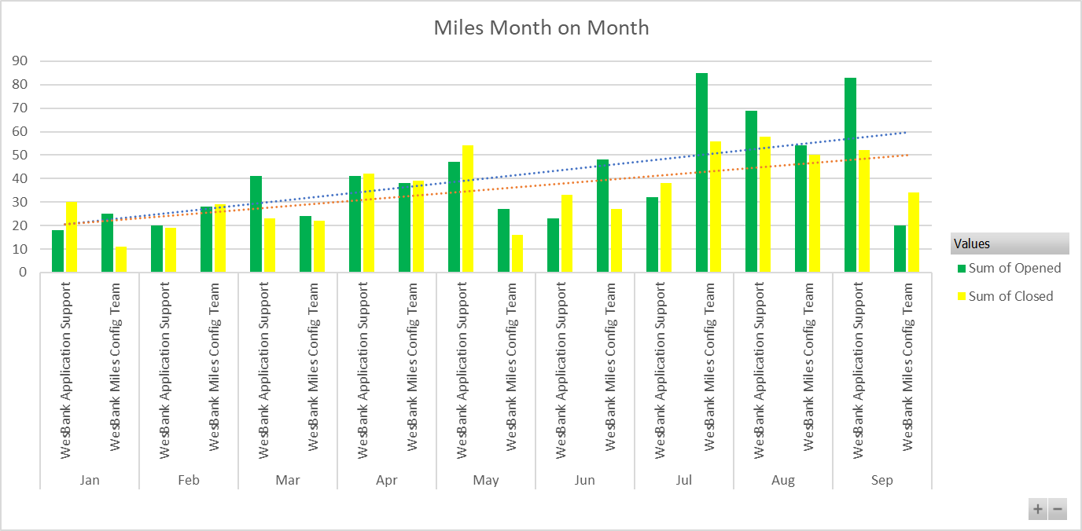

**Commentary:**

There has been an increase in the number of incidents due to business user roles changes after release deployments. A number of refinements and changes into the current process of working has come into the area for Config & Dev team. Training issues still remain within business as incidents raised are closed within the application support area providing clarity and guidance to business on how to utilize the functions in the application

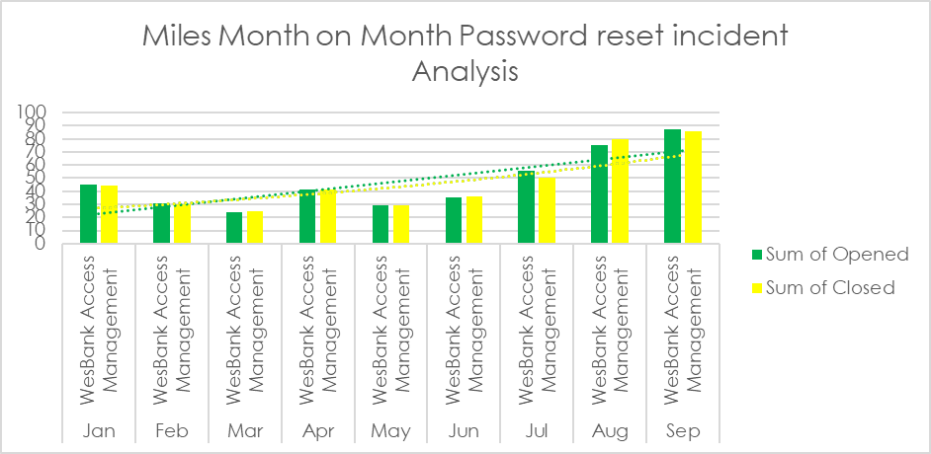

**Commentary:**

## Incident Age Analysis

|  |  |  |  |  |  |  |
| --- | --- | --- | --- | --- | --- | --- |
| **Number of Open Incident Age Analysis** | | | | | | |
| **Month** | **Sum of current** | **Sum of 31-60 Days** | **Sum of 61-90 Days** | **Sum of 91-120 Days** | **Sum of >120 Days** | **Sum of Total** |
| Aug-23 | 98 | 33 | 16 | 15 | 23 | 185 |
| Sep-23 | 64 | 74 | 24 | 9 | 27 | 198 |

**Commentary:**

## Incident and Service Management commentary

**Successes:**

* FNB team continue to work on ensuring that the **password** synchronization across on all systems applications occur without different teams' involvement and the user not having to interact with different IT teams. This will continue to be monitored by Service Management Office. The plan to have Autocard users reset their passwords on the FNB App has already been actioned however there is still items outstanding such as multiple FNB Teams engaging to streamline process once this goes live into Production.
* First Rand Group **Disaster Recovery** was successfully facilitated for all WesBank and FNB services consumed by FML business.

**Challenges:**

* There have been numerous issues being experienced on **Miles** that an official problem statement has been raised and these will continue to be tracked as one problem statement for the FNB Problem Management team for resolution however being attended to by the Miles Development team. There are also ongoing discussions and meetings for the team to understand and streamline standard operating procedures for Incidents, Problems and Changes. This will continue to be monitored by Service Management Office.
* With some known issues experienced impacting **CIC** and **Miles** thought to be of **internet connectivity**. The investigation continues with IT service managers and IT teams being present on the floor with the plan to ensure that all laptops are compliant with FRG security updates, educate staff to connect correctly to all available internet connectivity medium, however reinforcing that all **CIC** users need to be on **LAN** still continues**.**
* There was a failure of experienced slow response times on internal correspondence **emails**. The impact for FML Business was that no **emails** were queuing on **CIC** which resulted in poor SLA being attained. The root cause was there were delays caused by a flood of emails from another dev/test servers. All the preventative measures have been put in place.
* The following issue was experienced post **Disaster Recovery** which impacted FML call centres. MMC and MMP functions on **Autocard** were not working, with impact being that users could not load and approve quotes. IT had to recompile the code and restarted Applinx then it worked as system did not pick up their limits. This was tested and worked on post Disaster Recovery, so the team was unsure what was the root cause. This was noted as one of the issues experienced during Disaster Recovery. Later in the month the same issue resurfaced post a change implemented by the FNB AutoCard team, the team provided new links to access AutoCard as a new way to login and provided support over MS Teams chats with impacted users to manage escalations as the impact across business carried for over several hours.
* **Fleetactiv** billing failed and during the investigation all users were stopped from logging into the system to allow the technical teams to investigate further. As part of resolution which involved restoring the database then running the billing manually through the front-end by developer, while Server Admins and DBAs teams monitor. Furthermore, there was a FleetActiv Server upgrade the wekeend post this issue and no other issues were experienced during and post the change. New login links were provided to users.
* ACB payment on **FleetActiv** failed due to missing banking details missing deadline, however the extract validation was completed successfully. The impact was that no merchants were paid, multiple teams resolved this failure with several system changes implemented.
* The issue for **ImageNow** is proactively being monitored for the large sizes of mailboxes. The investigating team has created a rule on these mailboxes that will either move the large emails out of the Inbox and into a separate folder or forward the mail to someone in business so that it can manually be captured into ImageNow. The outstanding task is for business to provide people that the rule will send these large emails to that will be captured manually. This will be tracked by Service Management Office. The issue resurfaced however IT proactively intervened as names are still not received from business.
* **Network** issues triggered servers to be disconnected, with resolution being that the cables were removed, and the services started to recover. This impacted the 24 hours FML Call centre as the issue occurred after hours.

## Problems

**Tracking of Problem Statements and number of days open**

| **Date** | **Problem** | **Business Impact** | **Root Cause** | **Remediation** | **Preventative Measures** | **Incident Classification/Duration** |
| --- | --- | --- | --- | --- | --- | --- |
|  | | | | | | |
| 2023-01-24 /2023-08-03-Ongoing | **PRB0046248 –**  **Miles hanging errors** | Since inception of the application, various users experience timeouts on certain functions within the application | Additional fields that are added on the Miles application as a result of releases being implemented on the application are causing locks on the Database, an example would be due date field on the purchase invoice, selections are causing the application to go in a hung state.  There are various scenarios to be investigated with the vendor. | Investigations are underway with the Vendor, the task is being tracked and updated when these fixes are being presented.  There are various workarounds in place with the config team and business and as a result the problem will remain open until all these scenarios have been resolved. | Will be completed once all issues have been resolved (suggestion, all issues be documented and a definitive media library be created with the assistance of risk). | P4 Low/Urgency  All incidents closed.  Reactive  FNB reportable outage |

**Tracking of Problem Statements and number of days open**

**Noteworthy:** The Problem Management has moved into FNB ISS team, these problems are now tracked from there with weekly meetings with the technical teams.

* **518 Days - Implementing FNB SIP trunk for redundancy on WesBank voice lines**:
  + During a WesBank Telkom PRI voice line failure, WesBank is unable to route calls in an alternative manner. Depending on the nature of the failure it could result in these lines being down for an extensive amount of time and the affect is that our contact centers are unable to make and receive calls.
  + IT CIC Team installed BCX SIP trunk with full redundancy. However, FRG is unable to control what could possibly happen on last mile infrastructure.
  + The FNB SIP trunk is in place however the extension charge out is not. This has an impact on the IT Finance due to CDR pointing to FNB however Wesbank is paying for every incoming on smart access and toll-free calls pointed to the FNB SIP trunk.

**Risks**

* The risk that involves some **CIC** interventions (for all interactions happening on CIC (this includes telephony services, emails and attachments interactions to have a unique caller identity) so that FML business meets regulatory and compliance standards. Since there are development costs involved FML business will need to log RFS (Request For Service) and a project manager be assigned to facilitate this.

**IT Environmental Changes**

* + FRG Disaster Recovery 02 until 09-09-2023
  + FLEET AUTOCARD – September Release 15-09-2023 No impact
  + WesBank Planned Windows Server and Third-Party Patching 16/17-09-2023 FAIM down, CIC queueing delayed
  + Miles Fixes Change 22-09-2023 Miles down from 6pm-7:30pm
  + Fleetactiv server upgrade 26-09-2023 FleetActiv down from 6pm-8pm

# Transaction Stats

No Update received

# IT Infrastructure and Software Management

## Unsupported Technology

The following software is currently outdated and/or unsupported:

* + FROG Stack: The FROG software stack which includes, OBIEE, OFSAA, Hyperion, ODI, Infogix and Informatica needs to be upgraded as most of these platforms have reached end of support.
  + The project is progressing well, and we have reached the performance testing stage with all previous testing and concerns being resolved.
  + Hyperion and Infogix upgrade completed
  + OC4j 10G for BI: The Oracle software is outdated and unsupported. A migration to Power BI is currently in progress and the completion date is currently 24 to 36 months.
  + 2 x FleetActiv Servers: Servers were rolled back to Server 2008 R2 as part of the agreed process to halt the upgrade in favor of Miles replacement. A suitable date to decommission these environments are currently under investigation with and estimate been given for November 2025.
  + 1 x SharePoint Server: CWF is being tested on Server 2012 in QA. Compatibility problems with the sites are under investigation in QA.

## Unsupported Hardware

|  |  |
| --- | --- |
| **Application** | **Progress** |
| MegaFTP | The MegaFTP environment is extremely old and no connections can be made to a 19c database.  On SPIF a work around has been put in place to use the functionality of an Oracle 11g database to enable functionality on MegaFTP. This is a temporary solution as the Oracle 11g database will not be supported after 31 December 2020. |

## Upgrade Roadmap

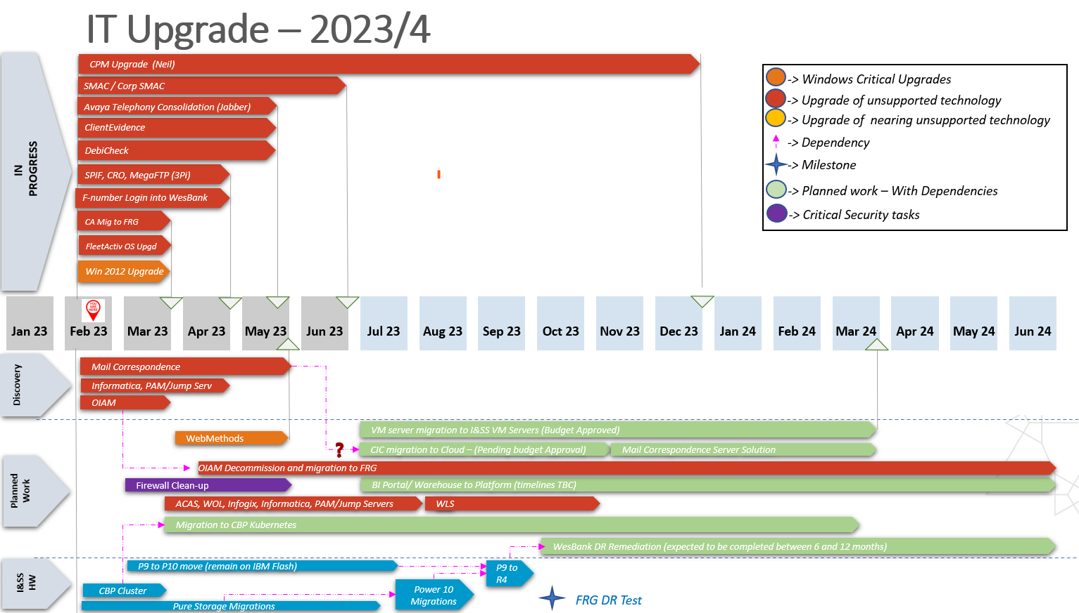

* Client Evidence – During the performance testing phase it was decided that the upgrade planned for May 2023 will be postponed to July 2023 to ensure all concerns can be alleviated and enough time can be given to all teams to correct the concerns.
* Fleetactiv currently on Windows 2008 and being tested on Windows 2019. Migration date currently estimated for October 2023 (best effort August 2023)
* SPIF upgrade – A new date for the upgrade is under investigation
* Pure storage and IBM P10 migration – Project to plan and start migration to the IBM P10 have been started.
* The Red 3 production/DR environment migration initially planned for the weekend of the 16th to 18th of June was postponed due to instability and performance concerns. Investigations with the vendors were conducted and minor environment configuration changes and data refresh was conducted which ensured that the stability and performance concerns were alleviated.
* New dates for the move to the P10s are being planned for the months of October and November 2023.

## 5.3 Batch Monitoring

The following Miles jobs fail every weekday and notification of errors was sent to business, as these errors are related to data, and Business involvement is required to rectify the data on the system.

**Stopped with Errors**

|  |  |
| --- | --- |
| Job name | Status |
| CRO Locate Supplier | Stopped with Business Error |
| CRO Fetch KYC Customer | Stopped with Business Error |
| CRO Locate Customer | Stopped with Business Error |
| Auto Take in vehicle for ET - Written Off | Stopped With System: TakenVehicle 5012578 Error Since the vehicle is not in use it cannot be taken in. |
| Set Telematics TPSC provider | Ended with Business Error |

**Ended With Business Error**

|  |  |
| --- | --- |
| Job name | Status |
| Charge-back managed maintenance invoicing | Ended With Business Error: The business partner with ID 5710476 is not a customer. |
| Charge back no contract | Ended With Business Error: The business partner with ID 5795355 is not a customer. |
| Generate consolidated invoice - Charge back license | Ended With Business Error: 5796034 Invoice payment information is missing. |
| Perform Distance Settlements after Contract Termination | Ended With Business Error: 5702861 The distance settlement is not allowed. There is already a later distance settlement. |
| Settlement (termination) invoicing | The fiscal period is now closed. Please enter a valid post date/fiscal period or reopen the fiscal period. |
| Renew AA FLEETCARE Roadside Assistance | Ended with Business Error: Failed to process tpsc(s) further. TPSC id(s) = 5017350 with error = 0 |
| Rental invoicing - Monthly - In Arrears - Fleet Managed – Cut off | Stopped with System Error Someone changed the same data in between. Please refresh your data before you save again. |
| Rental invoicing - Monthly - In Arrears - Fleet Managed – Cut off-14 | Ended With Business Error |
| Generate and Send Tax Invoice - Upfront (plan fee OEM) - Non-PO/ Invoice Generation Times | Ended With Business Error: 5005176  5018856,5018858 |
| Generate and Send Tax Invoice - Settlement invoice - Non-PO | Ended With Business Error: Unable to resolve document context 500061; none of the underlying document handlings gave a result. |
| Set RMT Collect and Pay Over TPSC provider | Ended With Business Error 5024743 No solution found for the lookup (lookup table 'RMT Collect & Pay Over suppliers' with id=500089). |
| Validate precomputed amendment quotes (prime interest rate bulk modification) | Stopped With System Error: |

This job **SOF_MT940_Payment_Impor**t failed on the following dates , business was informed that the bank account or account numbers were incorrect and these issues were resolved on the same day

|  |  |  |
| --- | --- | --- |
| Job name | Status | Date |
| SOF_MT940_Payment_Import | Stopped With System Error No bankaccount found for accountnumber | 07-Sep-2023 04:00 AM |
| SOF_MT940_Payment_Import | Stopped With System Error Could not open the specified file MILES_MT940_STATEMENTS | 01-Sep-2023 04:00 AM |

# Capacity View

## Business Analysis

|  |  |  |  |
| --- | --- | --- | --- |
| **Resource Name** | **Role** | **Employment Type** | **Assigned To** |
| Ndivhuwo Mkhabela | Business Analyst | Contractor | - M3 Post Implementation (tracking tickets raised and UAT) |
| Miehleketo Ndlovu | Business Analyst | Contractor | - M3 Production Support  - DBR Job Seats  - Direct Debit & Direct Credit process documents |
| Vikas Kathuria | Business Analyst | Contractor | - M3  - Miles/Autocard Data Integration  - SAPS job card & NSO |
| Mbali Shamu | Business Analyst (DM) | Contractor | - M3 |

## Development

|  |  |  |  |
| --- | --- | --- | --- |
| **Resource Name** | **Role** | **Employment Type** | **Assigned To** |
| Mandla Mthombeni | Developer | Contractor | - Production Support |
| Themba Sivate | Developer | Permanent | - Production Support |
| Nandipha Napakade | Developer | Contractor | - Production Support |
| Nkosinathi Mahlangu | Developer | Permanent | - M3  - Batch Monitoring and Management |
| Sibusiso Ndaba | Developer | Contractor | - M3  - Batch Monitoring and Management |

## Quality Assurance

|  |  |  |  |
| --- | --- | --- | --- |
| **Resource Name** | **Role** | **Employment Type** | **Assigned To** |
| Lindiwe Mhlongo | Senior Test Analyst | Contractor | -M3  -Miles October/November Releases |
| Abel Mphahlele | Test Analyst | Permanent | -M3  -Miles October/November Releases |
| Sandy Naidoo | Test Analyst | Permanent | -Miles Lookup Tables  -Miles October/November Releases |
| Luvuyo Silwana | UI Test Engineer | Contractor | -M3 Automation Scripting  - Automated Sanity Testing  - Regression Testing |
| Zenzele Jobe | Test Analyst | Contractor | -M3 Post Implementation Support  -Miles October/November Releases |
| Kevin Ndou | API Test Engineer | Contractor | -M3 Integration Testing |
| Nokuthula Ndlangamandla | Test Analyst | Contractor | -M3 Post Implementation Support  -Miles October/November Releases |
| Jongikhaya Tshaka | Test Analyst | Contractor | -M3 Post Implementation Support  -Miles October/November Releases |

## Architecture

|  |  |  |  |
| --- | --- | --- | --- |
| **Resource Name** | **Role** | **Employment Type** | **Assigned To** |
| Johan Stieler | Enterprise Architect | Permanent | - FML (50% allocation) |
| Sekhonyana Molapo | Solution Architect | Permanent | - FML IT (ALL)   * RT46 (SAPS Jobcard & NSO) * M3 * Miles/Autocard Data Integration * MMP * Miles LDAP Integration * Documents Repository |

|  |  |  |  |  |  |  |  |  |  |  |  |  |
| --- | --- | --- | --- | --- | --- | --- | --- | --- | --- | --- | --- | --- |
| **No** | **Date** | **Programe Name** | **Project Name** | **Project Priority** | **Process/Task Issue** | **Action Type (Note / Action / Decision)** | **Action Description** | **Action Owner** | **Due Date** | **Comments** | **Status** | **Architect** |
| 1 | 10-May-22 | FML | Macrocomm |  | Technical | Action | Macrocomm - Architecture | Kevin White | TBA | Session has with Retails team.  ITAB - 10 July CJP ARB - 17 Auh ITAB 2 - Scheduled for 24th Aug | Open | SK |
| 2 | 10-May-22 | M3 | Global Scape |  | Technical | Action | Miles - Global Scape - AC Data Integration | Zwelinjani | 15-Sep-23 | Saps JobCard folders - 27 Aug | Open | SK |
| 3 | 11-May-23 | M3 & CRO | CRO |  | Technical | Action | CRO - Customer Onbording Portal for Customers | Pravada | TBA | Technical Person is Mayuri This is corporate migraton for customer | Open | SK |
| 4 | 12-May-23 | M3 | BI Reporting |  | Technical | Action | BI Reporting and Replication DB | Shaun | 15-May | Technical Discussion have hhad with BI Team  Meeting Set up for 15 May to go through Pros & Cons | Open | SK |
| 5 | 10-May-23 | FML | Customer Portal |  | Technical | Action | Business Requirements for FML Customer Portal | Ayana Gantsu | TBA | The initiative is in the business requirement. | Closed | SK |
| 6 | 15-May-23 | FML | ConnectMe |  | Conceptual | Action | Review Connect me requirements and start with Conceptual architecture | Sekhonyana / Johan | 31-May | 15/05 Requirements to be verified. Interact with Hussein Patel | Open | SK |
| 7 | 15-Jun-23 | FML | Miles |  | Conceptual | Action | Cloud vs Inhouse hosting | Sekhonyana / Johan | 30-Oct-23 | Investigate cost and support for Hosting Miles on Sofico Cloud Platform | Open | SK |
| 8 | 10-Aug-23 | FML | AB Initio vs SQL vs Java |  | Technical | Decision | Using Ab Ibitio vs SQL vs Java to drop files in the IDB achive folder | Zwelinjani | 15-Aug | Discuss the best approach with the data Architect. The recomendation is to use the same Job Scheduler that GS uses to push files to AC. Push a a file to AC and Push the Archive to Archive directory | Open | SK |
| 9 | 15-Aug-23 | FML | Motomatix Proof of Concept |  | Conceptual | Decision | Using data from Motomatix to compare prices on quotations given by Merchants | Linda | TBA | Business has gone ahead to engage the Vendor without consultaion of IT & Architecture | Open | SK |
| 10 | 15-Jul-23 | FML | SAP JobCard and NSO |  | Technical | Action | Defining New Process for SAPS JobCards and NSO | Derrick | 15-Sep-23 | Specification for this process is still being finalised and requirements signed off | Open | SK |
| 11 | 16 Jul 23 | FML | Tracker -Fleet Tracking Automation |  | Conceptual | Action | Automation of the Vehicle Tracking Activation for FML | Aneesa | TBA | Prior engagement has been had with business and the vendor (Tracker) to determine highlevel process | Open | SK |

# FML PMO Overview

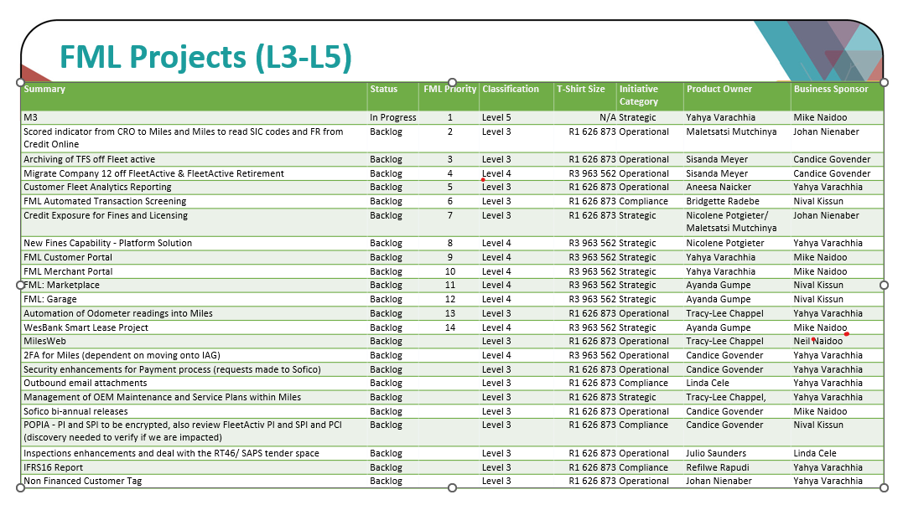

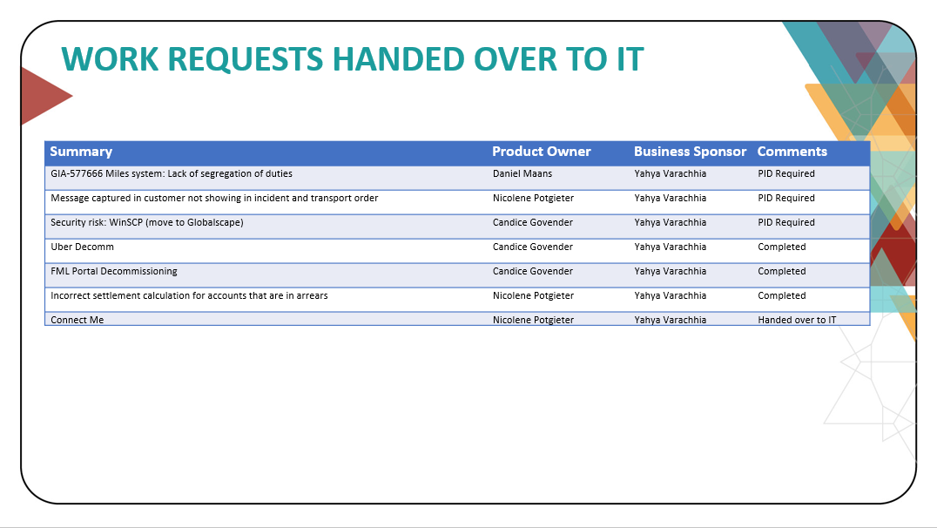

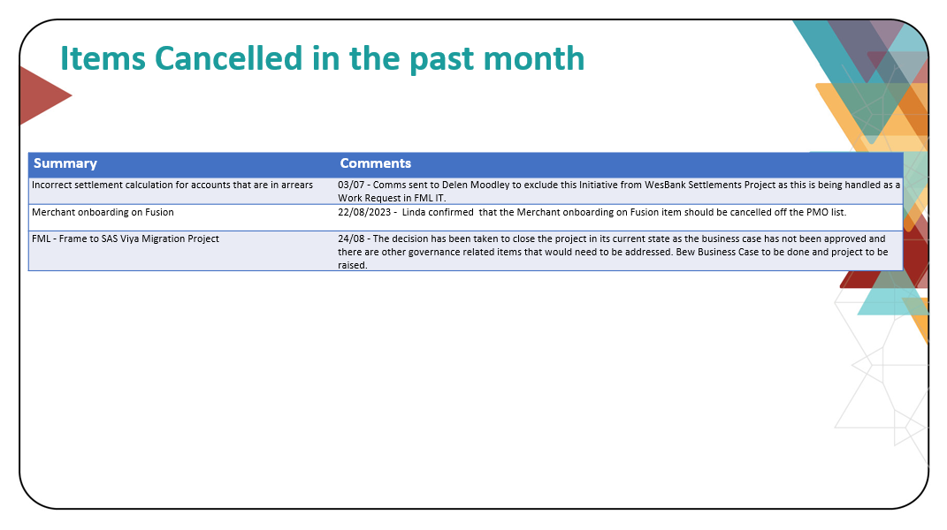

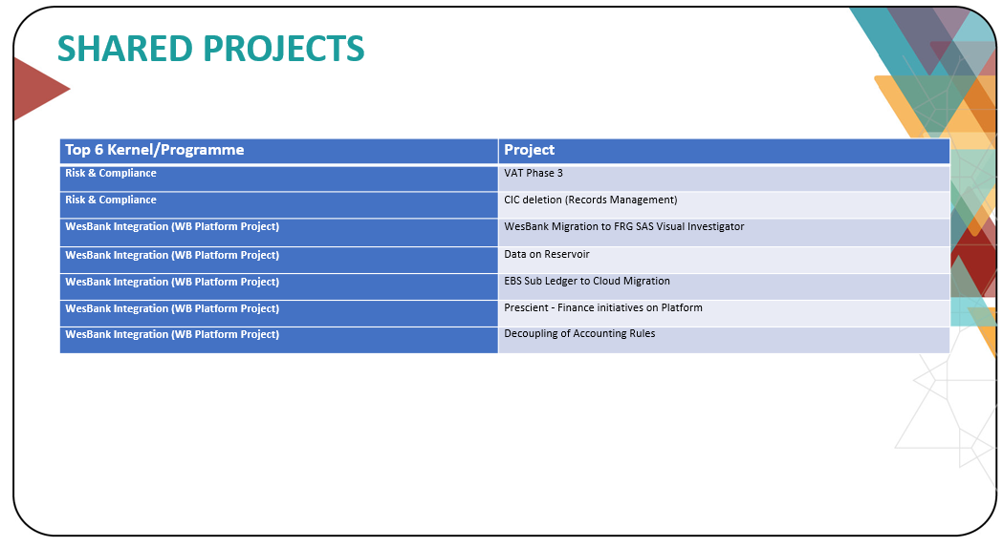

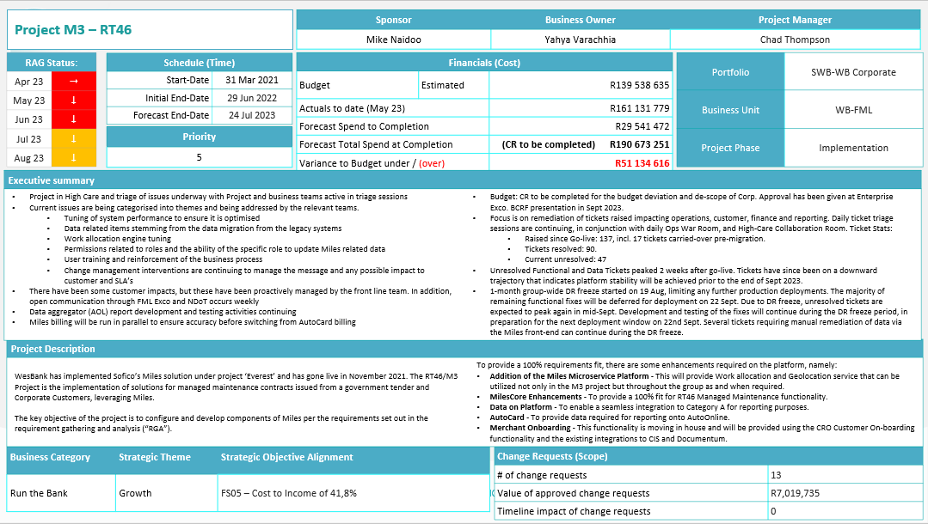

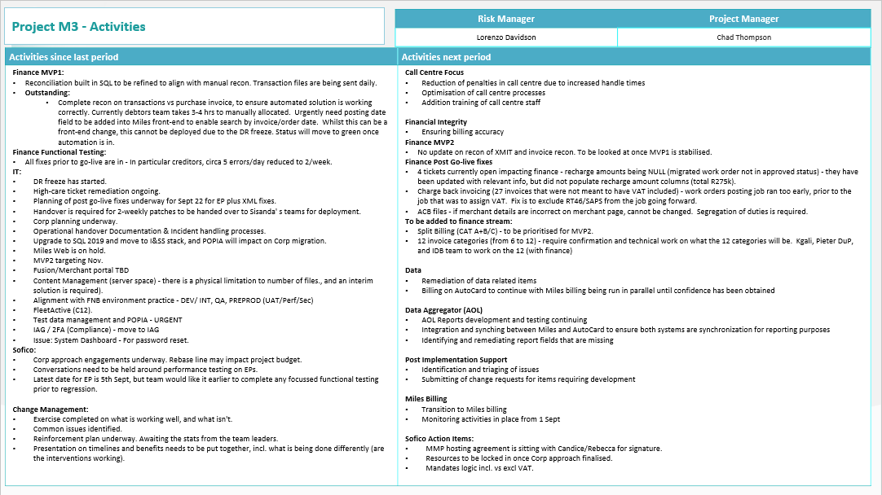

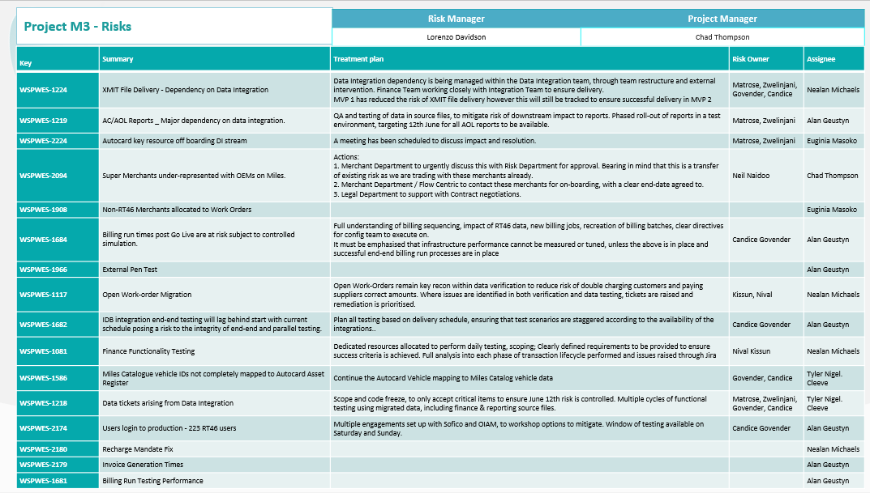

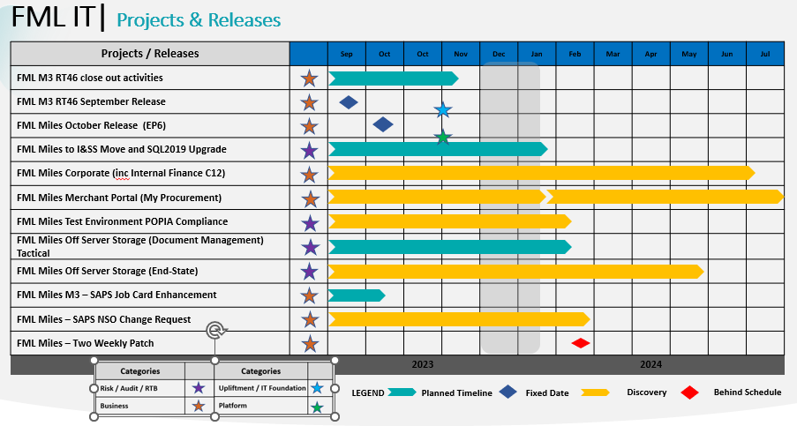

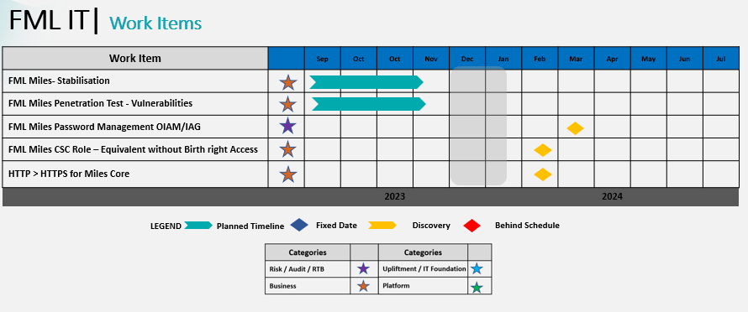

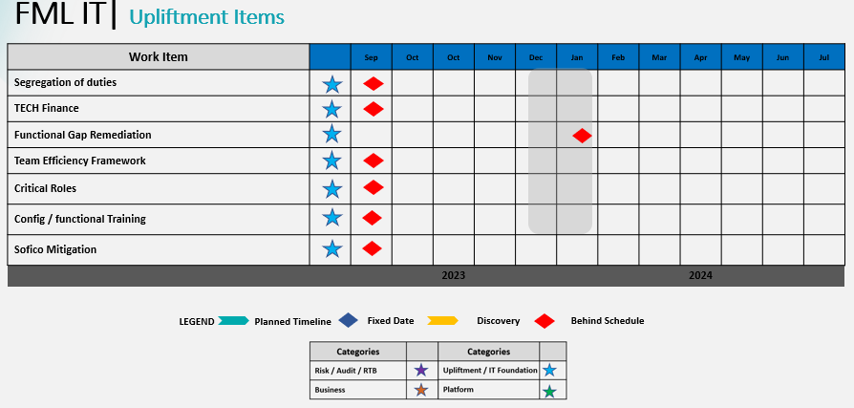

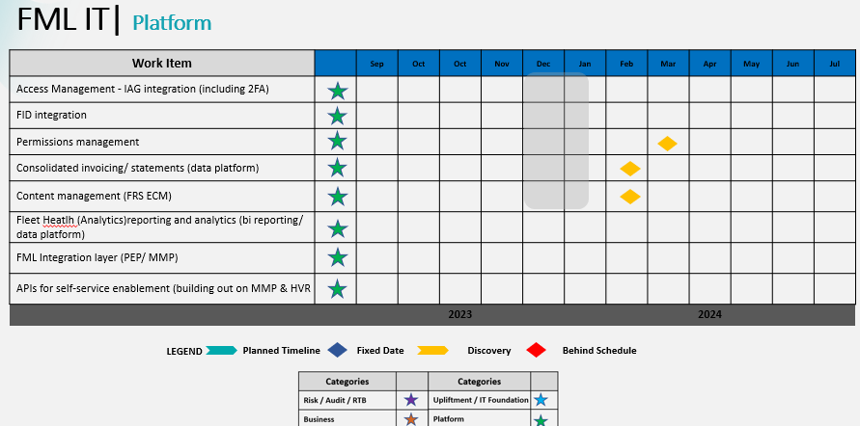

# Business Delivery

## Initiatives in Progress

|  |  |  |  |  |
| --- | --- | --- | --- | --- |
| Start Date | Release Date | Status / Phase | Request | System |
| Work Requests | | | | |
|  | 10/11/2023 | Testing | Incorrect settlement calculation for accounts that are in arrears | Miles |
|  | 10/11/2023 | Testing | SAPS Jobcard file Enhancement | Miles |
|  | 27/10/2023 | Testing | Benchmark pricing to pull per make and model | Miles |
|  | 27/10/2023 | Testing | System is not removing the existing Merchant after disapproving the Order | Miles |
|  | 27/10/2023 | Testing | M3 Prod - Mandate lookup Table using Total Amount Excluding VAT instead of +VAT | Miles |
|  | 27/10/2023 | Testing | User overriding WAE assigned supplier | Miles |
|  | 22/09/2023 | Testing | User to receive message to set RT46 Contract Termination Date to End-of-Month | Miles |
|  | 27/102023 | Testing | Miles Direct Debit Load Report Import error | Miles |
|  | 27/10/2023 | Testing | Interest rate change not reflected after customer invoicing jobs are executed | Miles |
|  | 27/10/2023 | Testing | Defaulting incorrect catalog part for vehicle part when no catalog part found | Miles |
|  | 27/10/2023 | Testing | NPS - incorrect Net Rental Compensation billing item | Miles |
|  | 27/10/2023 | Testing | M3 Prod - Automation on "invite to supplier" for accidents | Miles |
|  | 27/10/2023 | Testing | M3 Prod- Merchants- Soft block status functionality hard blocking payments and WO processing | Miles |
|  |  |  |  |  |
| Business Projects | | | | |
|  | 17/07/2023 | Post Implementation Support | M3 Implementation | Miles |
|  | TBC | On-hold | Miles Web Portal | Miles |
| IT4IT Projects | | | | |
|  | 15/09/2023 | Awaiting Implementation | FleetActiv Migration to Windows 2019 | FleetActiv |

## Initiatives Deployed

|  |  |  |
| --- | --- | --- |
| Release Date | Request | System |
| Work Requests | | |
| 22/09/2023 | M3 & Corp - On Accident Pre-inspection does not validate when cost and Recharge amount is captured - GoLive | Miles |
| 22/09/2023 | M3 - Data Integration - When a merchant is selected, a validation is needed on Draft --> Pre-Authorisation status change to ensure that a supplier that has been allocated has RT46 Agreement = TRUE | Miles |
| 22/09/2023 | M3 & Corp - On Accident Pre-inspection does not validate when cost and Recharge amount is captured - GoLive | Miles |
| 22/09/2023 | M3 - Data Integration - When a merchant is selected, a validation is needed on Draft --> Pre-Authorisation status change to ensure that a supplier that has been allocated has RT46 Agreement = TRUE | Miles |
| 22/09/2023 | M3 - Bypass the Required Documents to Activate Supplier - PostGoLive | Miles |
| 22/09/2023 | CORP - Main Repair Order switching to OPL contract when loading accident claims | Miles |
| 22/09/2023 | M3 Prod - SAPS TO + TRACKING is being sent to supplier instead of a Customer | Miles |
| 22/09/2023 | M3 Prod - Additional Roles for "Work Order Reporting" selection | Miles |
| 22/09/2023 | ACB Payments | Miles |
| 22/09/2023 | [Purchase Invoice Posting Date to be added to "Find Supplier Invoices" Selection](https://sofico.atlassian.net/browse/WBM3QA-1137) | Miles |
| 22/09/2023 | M3 PROD- ADDITIONAL STATUS REQUIRED ON ASSESSMENT ORDERS | Miles |
| 22/09/2023 | Tax Invoice Monthly 21st. | Miles |
| 22/09/2023 | Recharge Amount is Null on Work-Order resulting in incorrect Chargeback Amount | Miles |
| 22/09/2023 | M3 Prod - Additional "Suppliers Quote" in TO & AO Not Working Correctly | Miles |
| 22/09/2023 | M3 PRODUCTION / USER ROLES ACCESS / MANUAL SELECTION OF STATUSES ON ASSESSMENT ORDERS | Miles |
| 22/09/2023 | M3 Prod- Merchants Department- Cannot create or update merchant codes | Miles |
| 22/09/2023 | M3 Prod - Work Allocation Engine (WAE) manual change report | Miles |
| 22/09/2023 | On modify contract error received SofBoException 111 with arguments Get|SofDataTypeArray because index 0 is out of bounds | Miles |
| 22/09/2023 | M3 Prod - Exclude RT46/SAPS contracts from 'Schedule to Master Agreement' job | Miles |
| 22/09/2023 | Prod - We need to change the quotation template for SAPS and RT46 to make the cost centre a mandatory field to insert | Miles |
| 22/09/2023 | Prod - RT46 Manual Supplier Selection - It seems like some supplier might be missed by the Selection or Custom SQL | Miles |
| 22/09/2023 | M3 Prod - Hard Block with Supplier Labour Rate Lookup Table on Work Order | Miles |
| 22/09/2023 | Prod - The Transmission Date seems to not be updating as the order progresses through the workflow | Miles |
| 22/09/2023 | Remove ability for Users to manually change Purchase Invoice status (using the dropdown) | Miles |
| 22/09/2023 | User to receive message to set RT46 Contract Termination Date to End-of-Month | Miles |
| 22/09/2023 | Prod - Clearance Document not pulling in the correct Email Contacts from Customers (eg. SAPS) | Miles |
| 22/09/2023 | M3 Prod - Tracking document populating incorrect pre-auth number - JIRA (atlassian.net) | Miles |
| 22/09/2023 | SU ACC SALES COSTS job still not running | Miles |
| 22/09/2023 | Forklifts loaded in hours but mileage was captured in kms WBM3QA-1034 | Miles |
| 22/09/2023 | TPSC:File Imports - Import Licensing Details from Certrack | Miles |
| 22/09/2023 | Weekly DiskDrive upload failed, to investigate and rectify so that upload is successful. | Miles |
| 22/09/2023 | JASPER: Please add exterior colour on the schedules | Miles |

## Total Deployments per Classification

{input of graph for changes per classification – Change Control}

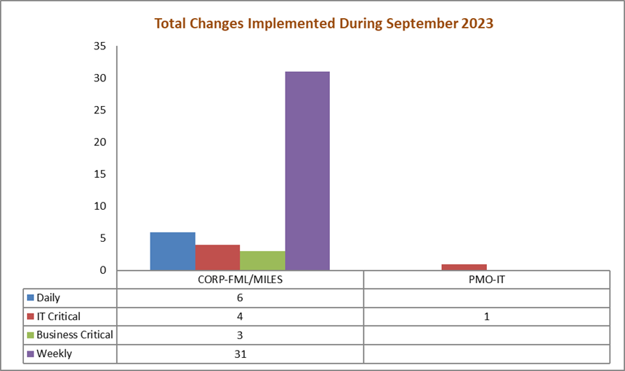

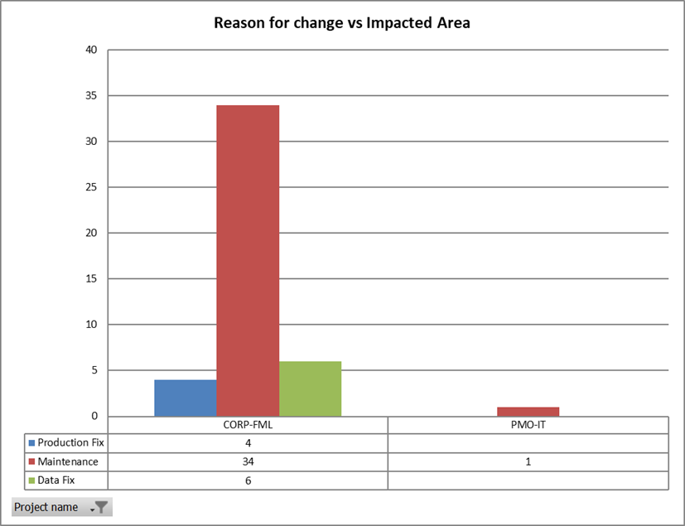

|  |  |  |  |  |  |
| --- | --- | --- | --- | --- | --- |
| **Issue key** | **Planned Release Date** | **Summary** | **Work Type** | **SN Incident I.D** | **Release Category** |
| FML-5169 | 2023/09/28 10:30 | Blaine is receiving error messages when he processes payments on Fleet Activ. List of the Deal numbers is attached. | Production Fix | INC6138364 | IT Critical |
| FML-3625 | 2023/09/22 18:00 | TPSC: Ctrack: Telematics Renewal Orders not generating for CTrack Fleet) | Production Fix | INC4589948 | IT Critical |
| FML-5197 | 2023/09/26 18:00 | Issue on Miles - We are unable to change the status manually to "Unable to conduct inspection" | Production Fix | INC6161144 | IT Critical |
| FML-4534 | 2023/09/26 18:00 | Move FleetActiv to 2019 Server | Maintenance |  | IT Critical |
| PMOIT-1117 | 2023/09/15 18:00 | FleetActiv move to Server 2019 | Maintenance |  | IT Critical |
| FML-5216 | 2023/09/29 10:08 | ACB payment failed on 28/09 due to missing RT46 details. post the fix on the 2 merchants the due date needs to be updated to 29/09 to avoid R250k loss | Production Fix | INC6177861 | Business Critical |
| FML-5176 | 2023/09/26 14:00 | Re-activate terminated contracts | Data Fix |  | Business Critical |
| FML-5177 | 2023/09/26 16:00 | Update billing items | Maintenance |  | Business Critical |
| FML-4414 | 2023/09/22 18:00 | TPSC:File Imports - Import Licensing Details from Certrack | Maintenance | RITM1663476 | Weekly |
| FML-4546 | 2023/09/22 18:00 | SU ACC SALES COSTS job still not running | Maintenance | INC5621108 | Weekly |
| FML-4638 | 2023/09/22 18:00 | UNABLE TO MODIFY CONTRACT NO. 1000120519 | Maintenance | INC5217546 | Weekly |
| FML-4901 | 2023/09/22 18:00 | DiskDrive upload failed | Maintenance | INC5914629 | Weekly |
| FML-4961 | 2023/09/22 18:00 | Purchase Invoice Posting Date to be added to "Find Supplier Invoices" Selection | Maintenance | INC5958115 | Weekly |
| FML-4987 | 2023/09/22 18:00 | M3 Prod: Forklifts loaded in hours but mileage was captured in kms WBM3QA-1034 | Maintenance | INC5869972 | Weekly |
| FML-5001 | 2023/09/22 18:00 | M3-Recharge Amount is Null on Work-Order resulting in incorrect Chargeback Amount | Maintenance | INC5983665 | Weekly |
| FML-5015 | 2023/09/22 18:00 | M3 Prod - Additional "Suppliers Quote" in TO & AO Not Working Correctly WBM3QA-1153 | Maintenance | INC6001975 | Weekly |
| FML-5016 | 2023/09/22 18:00 | M3 Prod - Additional Roles for "Work Order Reporting" selection WBM3QA-131 | Maintenance | INC6001989 | Weekly |
| FML-5036 | 2023/09/22 18:00 | M3 - Bypass the Required Documents to Activate Supplier - WBM3QA-983 | Maintenance | INC6017731 | Weekly |
| FML-5037 | 2023/09/22 18:00 | M3 Prod - [WBM3QA-1160] M3 Prod- Merchants Department- Cannot create or update merchant codes | Maintenance | INC6017729 | Weekly |
| FML-5038 | 2023/09/22 18:00 | M3 Prod - [WBM3QA-1125] M3 Prod - SAPS TO + TRACKING is being sent to supplier instead of a Customer | Maintenance | INC6017693 | Weekly |
| FML-5040 | 2023/09/22 18:00 | M3 Prod - [WBM3QA-1075] CORP - Main Repair Order switching to OPL contract when loading accident claims | Maintenance | INC6017658 | Weekly |
| FML-5051 | 2023/09/22 18:00 | M3- User to receive message to set RT46 Contract Termination Date to End-of-Month | Maintenance | INC6058031 | Weekly |
| FML-5054 | 2023/09/22 18:00 | M3-WBM3QA-1175- Prod - The Transmission Date seems to not be updating as the order progresses through the workflow | Maintenance | INC6060841 | Weekly |
| FML-5061 | 2023/09/22 18:00 | M3- WBM3QA-1180 | Maintenance | INC6060742 | Weekly |
| FML-5063 | 2023/09/22 18:00 | M3-WBM3QA-1174 | Maintenance | INC6060691 | Weekly |
| FML-5064 | 2023/09/22 18:00 | M3-WBM3QA-1173 | Maintenance | INC6060684 | Weekly |
| FML-5065 | 2023/09/22 18:00 | M3-WBM3QA-1168 | Maintenance | INC6060679 | Weekly |
| FML-5066 | 2023/09/22 18:00 | M3-WBM3QA-1164 | Maintenance | INC6060671 | Weekly |
| FML-5067 | 2023/09/22 18:00 | M3-WBM3QA-1163 | Maintenance | INC6060665 | Weekly |
| FML-5068 | 2023/09/22 18:00 | M3-WBM3QA-1145 | Maintenance | INC6060658 | Weekly |
| FML-5070 | 2023/09/22 18:00 | M3-WBM3QA-1109 | Maintenance | INC6060642 | Weekly |
| FML-5071 | 2023/09/22 18:00 | M3-WBM3QA-945 | Maintenance | INC6060633 | Weekly |
| FML-5082 | 2023/09/22 18:00 | M3TICKET LOGGED FOR JIRA TICKET WBM3QA-1156 ,THIS TICKET WAS LOGGED AS SOME USERS ON MILES HAVE MANUAL ACCESS TO CHANGE STATUSES AND THIS SHOULD NOT BE THE CASE | Maintenance | INC6078465 | Weekly |
| FML-5151 | 2023/09/22 18:00 | M3 & Corp - On Accident Pre-inspection does not validate when cost and Recharge amount is captured - GoLive | Maintenance | INC6057901 | Weekly |
| FML-5153 | 2023/09/22 18:00 | INCIDENT LOGGED FOR TICKET NUMBER - 1144 | Maintenance | INC6049589 | Weekly |
| FML-5156 | 2023/09/22 18:00 | Remove ability for Users to manually change Purchase Invoice status (using the dropdown) | Maintenance | INC6024257 | Weekly |
| FML-5170 | 2023/09/22 18:00 | M3 Prod - WBM3QA-1186 Tracking document populating incorrect pre-auth number | Maintenance | INC6138419 | Weekly |
| FML-5171 | 2023/09/22 18:00 | WBM3QA-1189 -Customer clearance documents duplicating parts and cost | Maintenance | INC6138894 | Weekly |
| FML-5183 | 2023/09/22 18:00 | WBM3QA-1162 - Work Allocation Engine (WAE) manual change report | Maintenance | INC6146185 | Weekly |
| FML-5105 | 2023/09/18 14:30 | please reset Miles password | Data Fix | INC6060580 | Daily |
| FML-5022 | 2023/09/01 12:00 | Vehicle Description Change 20230901 | Data Fix |  | Daily |
| FML-5083 | 2023/09/13 14:00 | IncorrectVehicleDescription - daily change | Data Fix |  | Daily |
| FML-5099 | 2023/09/15 14:00 | Incorrect vehicle description 20230914 | Data Fix |  | Daily |
| FML-5146 | 2023/09/21 15:00 | Incorrect vehicle description - 20230919 | Data Fix |  | Daily |
| FML-4616 | 2023/09/22 18:00 | JASPER: Please add exterior colour on the Schedules | Maintenance | INC5771003 | Daily |

## Sofico Service Desk

1. Ticket Statuses - YTD by month

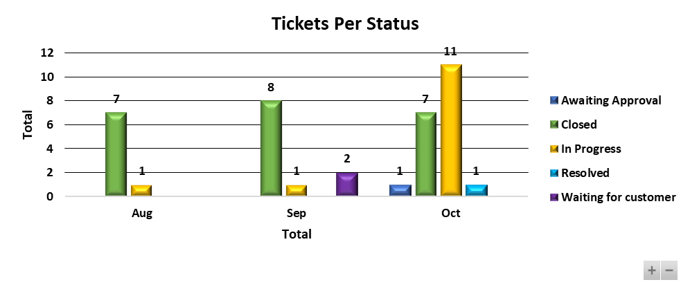

Tickets Awaiting Approval and Customer feedback

* SDWBSA-360 – Business will not go through with the change (To be closed)
* SDWBSA-382 – Error logs need to be sent to Sofico for further investigations
* SDWBSA-417 – Feedback is required to close the ticket (To be closed)

1. Ticket Severity Classification - YTD by month

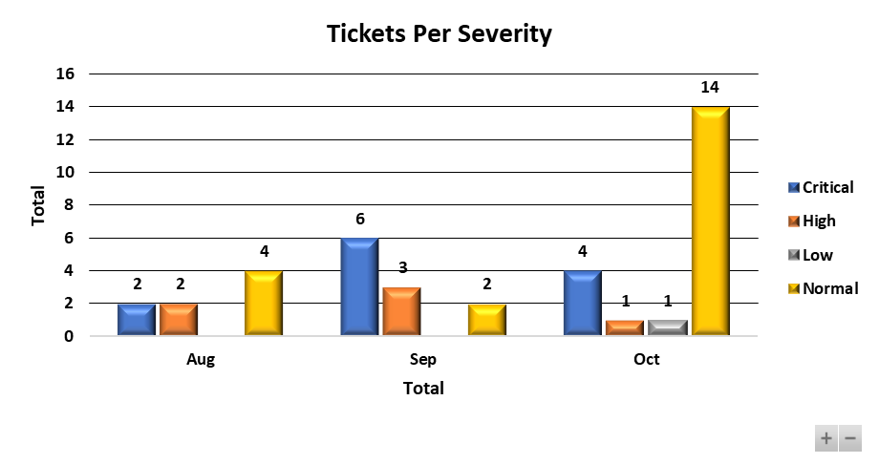

1. Ticket Volumes Changes vs Incidents - YTD by month

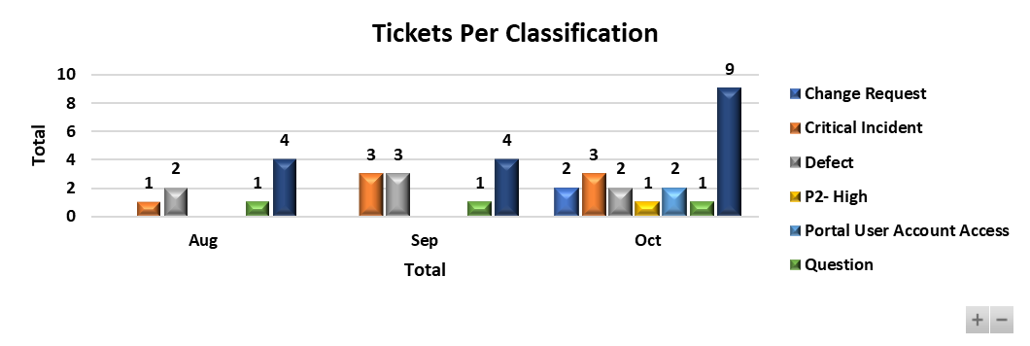

1. Invoices from Sofico Tracking – Due to be paid

|  |  |  |
| --- | --- | --- |
| **Reference No.** | **Description** | **Amount** |
|  | EP5 on 2022.2 20230522_2WK | R 22.686,94 |
|  | EP6 on 2022.2 20230522_2WK | R 22.686,94 |
| SDWBSA-312 | Everest Business Consulting | R 533.144,08 |
|  | Hosting MMP - Sep 2023 | R 172.380,98 |
|  | Hosting MMP - October 2023 | R 172.380,98 |
| SDWBSA-337 | Changes to debit order payment reference | R 310.916,23 |
| SDWBSA-388 | Business Consulting (September 2023 to December 2023) _WO008 | R 5.708.407,54 |
|  | Maintenance Fee (15/08/2023 - 31/12/2023) - Prorata M3 Contracts | R 1.419.813,63 |

# Quality Assurance

* Performance Testing – No performance testing conducted in September 2023.
* Security Testing – No security testing conducted in September 2023.
* Functional Testing – The QA team tested the 22 September 2023 Miles release.
* Miles Test Cases – There are 939 test cases on ALM Quality Centre.

# HR

The headcount remains unchanged for the month of July.

**Headcount:**

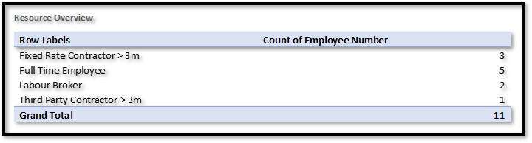

**Vacancies:**

* 1 x Technical Team Lead (Replacing Leeto Modutoane)
  + Status – interview stage

**Contract extension motivated for:**

* 1 x IT Platform Lead (Gordon Marriday)
  + Status – Contract extension motivation stage & pending Segment approval (not yet submitted to segment)

# IT Risk

# **1.** **FML IT Risk Overview – Executive Summary**

*The overall WesBank Fleet Management and Leasing IT Risk Profile remains Very* ***HIGH*** *and increasing for the period under review (September 2023).*

*Key areas of concern remains around the post M3 go-live tickets spike around Miles’ functionality and data integrity negatively affecting the RT46 Contract linked penalties provisions, recurring finance (debit order run and ACB payments) issues in production, stability and vulnerability concerns that comes with the utilisation of the FML legacy systems (i.e., FleetActiv) and strengthening of the overall FML IT control environment through closing of the current open IT risk events and incidents and their root causes, with a Very High Impact to the FML Business. An IT Upliftment plan has been put in place to address identified gaps; however, the plan is being re-baselined pending headcount approval.*

*Below is a view of risk rating and risk movement across the profile.*

|  |  |  |  |
| --- | --- | --- | --- |
| **Operational Risk Profile** | **July 2023** | **August 2023** | **September 2023** |
|  |  |  |

High-level View of the Current Open Items Influencing the FML IT Risk Profile:

**Audit findings:**

* There are currently nine (9) open FML IT Audit Findings being tracked in the month of September 2023.
* Of the nine (9) findings, three (3) findings are due at the end of October 2023; two of the three on track for the due date, while a possible extension is on the cards for one, IT Risk in discussion with management for the request to be logged. The finding pertains to ‘Governance process not followed prior to deployment of the Miles system role matrix into production’ (GIA-582554).
* Three (3) out of the nine (9) findings are tracking for resolution by the end of November 2023; one on track for the due date while the other two are on a possibility for extension, IT Risk in discussion with management for the request to be logged. The finding pertains to ‘Uniform Resource Locators (URLs) not secure – Miles Core’ (GIA-582343) and ‘Logical access: Non-compliant password expiry on Miles’ (GIA-582344).
* The last three (3) findings are tracking for resolution in 2024; all on track for the due date.

**Compliance:**

***FML IT Security Training Completion:***

* FML was seating at 99.21% overall for the four (4) open modules on Know-Be4 as at the end of September 2023.
* The Info security stats for FML is on track for all training modules referencing; (1) Realty Bytes: Ransom Gangs, (1) Spot the Bad Attachment and (1) Spot the Bad link. All modules are tracked above the acceptable threshold of 95%. The incomplete % is due to long leave.
* Overall FML compliance is impacted by the new module, Business Email Compromise that was rolled out in June with a deadline of 31 September. The 0.79% incomplete % was due to staff that was either on leave or recently terminated their employ with the bank.

**key Risk Indicators (KRIs):**

Currently all IT Risk KRIs are tracking and reported at a WesBank level. FML specific KRIs still under development, engagements ongoing between FML IT, IT Risk and WesBank IT for FML specific KRIs to be defined in line with the critical SLA deliverables for the business unit. FML specific Cost Centres required for configuration into Open Pages to enable this change.

**Monitoring:**

**FML Role Based Access Reviews on Miles:**

* Miles Look-up Tables Access Rights: Issue Resolved on the 4th of September, IT Risk is monitoring post implementation impact of the change. The deployed solution however was limited to corporate/ BAU users it didn’t cater for RT46/SAPS or M3 migrated users. The project team is currently working on a solution to add the RT46/SAPS users to the Lookup Tables’ roles and role definitions.
* Audit Logs on Lookup Tables: Still tracking for resolution beyond the targeted date. A change for audit logs to all look-up table changes to be deployed in line with the approved FRS. Issue prioritized for resolution before the end of October 2023.

**Miles Stabilisation:**

* Stabilization and post implementation support is still underway.
* Performance issues continue to be noted within the Miles Environment, with number of instances noted within the RT46 call centre space, where various users experience timeouts on certain functions within the application. A problem ticket has been raised to this effect **(PRB0046248 –** Miles **hanging errors),** issue under investigation and the ticket remains open until a permanent solution has been found.
* EPs continue to be deployed without performance testing performed on the patch prior to deployment (Resource limitation highlighted).
* Resources, prioritization, Emergency Patches failing upon QA testing leading to Eps not being deployed for the month as planned and the various code freezes (month-end freezes) in between impacts resolution of tickets that impact critical business operations.
* The plan is to close the M3 programme by 2023/11/30, pending business approval.
* There is increased focus between Project Management and Risk Management to review the Governance Health of the programme prior to closeout.
* An IT upliftment plan is being put together to deal with and address key gaps identified in the current operating model and supporting capabilities.

**Project M3:**

The M3 Miles Project went live officially on the 24th of July 2023. The go-live was not without challenges and outstanding tickets, defects, and post go-live issues, prioritised for resolution as part of emergency incremental patches for the month of September and October 2023.

**Post Go-live Tickets – Enhancement Back-log:**

All enhancements tickets are being tracked and will be prioritized prior to the project closure targeted for the revised date of 30 November 2023.

**IT Continuity**

**Blackout Planning**: Planning for a complete electricity grid failure event is underway. Particular attention is being provided to critical business services in Rest of Africa regions and those that may be required to be kept online in support of government services (mainly in the FML environment); all other systems to be subject to graceful shutdown after the wind-down of business activity. The approach is in alignment the broader R&C resilience strategy as well as with planning expectations communicated by the South African Reserve Bank. The revised blackout plan is being reviewed along with the identification of critical staff required for ongoing system maintenance and graceful shutdown; with whom addendum contracting will be concluded. This is driven at a WesBank IT and Commercial Segment level.

**DR Capability Risk:** Mitigation of key DR capability risks awaits completion of the remediation plan for the DR which has been defined, aligned to FNB strategic data centre planning and approved. Full implementation bears a dependency on the FNB Data Centre strategy flight plan, however the target implementation is anticipated by November 2023. Further implementation of the remediation plan will continue once the migration has completed, with detailed planning being outlined for the necessary remedial steps and establishment of a Red4 DR presence. This is also tracking at WesBank IT Risk level.

**Miles DR Test:** Miles was included in the Group DR that took place in September 2023. The system failed over from Red 1 (production) to Red 3 (DR) on 2023/09/02 and failed back to Red 1 on the 2023/09/09. No material incidents reports pending the final WesBank DR report.

**Lack of Miles High Availability (HA) capability:**

Although HA capability for Miles was implemented as per approved architectural design, the capability has been noted as being inoperable subsequent to a Miles patch implementation in September 2022 which changed the infrastructure environment. In December 2022, the vendor (Sofico) recommended upgrading to the latest JBOSS version, however this did not resolve the issue and escalation to the vendor for root cause assessment and resolution continued. Sofico requested additional time to identify the cause of the issue which was then approved by FML IT. A suitable fix has not yet been identified and the issue leaves the Miles application in production without suitable HA capability. The issue compromises the ability to rapidly failover the application if one application cluster fails, however the disaster recovery capability for the system is still functional. The potential impact may include operational downtime outside defined business appetite. This is also tracking at WesBank IT Risk level.

**IT Risks - Top of Mind IT Risks:**

* **Critical Financial Jobs Failures:**
* **ACB Payment Failures** – Payments Run are currently executed manually. A fix from Sofico is ready that will force users to follow the correct process when adding order items in the work order, so that we may longer encounter missing contract cost centres. The fix was part of the Emergency Patch (EP5) that failed testing and was rejected by CAB for the initial target date of 22 September. This patch will be part of the now updated Patch (EP6) that is currently being tested by the FML QA team, targeted for deployment on the 13th of October we will resume payments automation again. Until then, recurring incidents of payment run failure are to be expected.

* **Debit Order Run Failures** – Resulted due to field character issues between Miles and Fintegrate. The root cause is linked to data issues. The fix for this issue was also part of the Emergency Patch (EP5) that failed testing and was rejected by CAB for the initial target date of 22 September. This patch will be part of the now updated Patch (EP6) that is currently being tested by the FML QA team, targeted for deployment on the 13th of October we will resume payments automation again once deployed. Until then, recurring incidents of debit order run failure are to be expected.

* **FleetActiv September Billing failure (INC 6179574) and Double Billing -** The billing run failed on the 20th of September 2023 as follows: Task Launcher returned error code: 2 running with user WESBANK\svc win automation. - This usually indicates that the connection to the DB failed. Solution: The FleetActiv Dev Team then ran the billing run manually by running the batch file from the CMD line and not using the Task Scheduler. This was a temporal solution while the issue is being investigated.
* A subsequent issue was then noted on the 27th of September 2023 when the FML Finance team noticed that statements on fleet active for the internal accounts were billed for October rentals as well, showing double billing for the month of September 2023. The arrears were showing in + 180 days.

* **Duplicate and Missing Invoices on MVP1** - Issues found are as follows:
* Transactions did not send (potentially 1900 records) for AutoCard suppliers not on Integration Database.
* The file from 1 September for 31 September was rejected (about 861 records) - Missing transactions is estimated at R35.5m.
* The amount applicable to Merchants not on AutoCard stands is estimated at R25.9m - The remaining R9.5m needs to be analysed to identify why it has been excluded/missed.
* **Action Plan**: The risk event is still under investigation; this includes root cause and corrective action.

* **MacroComm and ConnectMe– IT and Risk Onboarding Assessment Not Performed Upon Onboarding of the MacroComm Service.**
* MacroComm – Initial request rejected due to the unknown state of the system and security architecture. Further assessment was presented to ITAB on 2023/09/21. MacroComm was approved for the Shoprite account only.
* ConnectMe – ITAB presentation not confirmed, to be prioritized.

* **Unsupported Technology – Legacy Systems:**
* FleetActiv is running on an unsupported operating System (Windows 2008 R2 Software). A hardware upgrade was recently performed on the application moving the system hardware from the 2008 version to the 2019 version. The upgrade was performed on the 26th of September 2023.

# Security

* + Vulnerabilities: 4 Perimeter vulnerabilities (medium risk) exist relating to SSL certificates, affects servers used by FML that has not yet been addressed. 25 critical or high-risk network vulnerabilities were detected on the reporting period. The IT Operations team are investigating and a plan for remediation will be put in place. Due date to be determined once investigations has completed.
  + Unsupported Operating Systems: 2 out of support OS (Windows 2008 R2) remain within the FML environment that needs to be resolved. Plans are in place for the decommissioning of these servers – End October 2023.
  + Unsupported Databases: There are 10 unsupported databases remaining within the FML space (down from 10), most relating to minor version upgrades (unsupported version vs in supported database). In addition, several of these picked up are related to bin/install files not removed after upgrade and needs to be removed. The DB admins have logged this as a hygiene action to remediate.
  + Security Awareness training: Well, done to FML team, nearly all of the employees have completed all their training The latest statistics are:
* 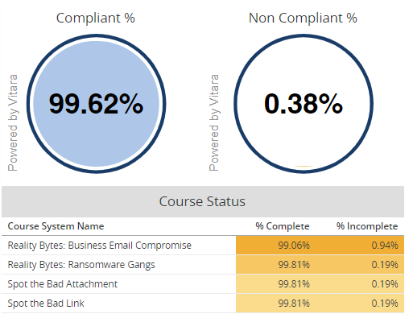
  + AD hygiene: Ongoing Active Directory hygiene is performed by the Ops team to align to group standards and to remediate any user or resource related issues in AD. At present, WesBank FML does not have any hygiene gaps in AD.
  + PAM: All system administrators are being enrolled into Beyond Trust – the Privileged Access Management System; this includes DBA (database administrators), operations teams, production support as well as system administrators (business and IT). The administrators will then have to use their privileged access booked out from the Beyond Trust system to perform any admin functions. Due date is for end of October 2023.

# **Finance**

## Financial Performance: FML YTD Aug FY24



**Commentary:**

**Staff Costs:** Staff costs is below budget by 15%. This is a result of 3 Vacancies in the area and BA's budgeted for from July only transferring in from August. This is offset by one BA who transferred in but was not budgeted for and 1 resource is expected to be 100% recovered but is currently not recovering on M3

**Attrition** cut relates to cuts loaded for expected natural attrition

**Professional fees:** Professional fees budget relates to new managed service vacancy requested during budgets which has not yet been filled. Actuals relate to M3 resources who are incorrectly paid in this area and should be in CC6894 (Kgali, Adriaan and Heunis)

**Telecommunication:** The costs relate to Telephone landline and 3G Data Costs. This is currently over budget and is based on usage.

**Charge-outs** are over budget mainly due to the REMS charge, coming through as a direct cost since team moved to CBP

**Project Recoveries** are below budget due to BA recoveries budgeted from July only coming in August; perm resources are slightly under recovering and 2 resources budgeted for not recovering at all

## Financial Performance: Project Recoveries YTD Aug FY24







## Financial Performance: Human Capital Information YTD Aug FY24





## Financial Performance: Allocated Costs YTD Aug FY24







# General

Please note that a group DR test will be conducted between the 2nd and the 9th of September 2023.

* General environments freeze between 18th of August to 17th of September
* Production environment impact on 2nd and 9th of September
* Non-production environment impact between:
  + 1st of September and 5th of September
  + 8th of September and 12th of September

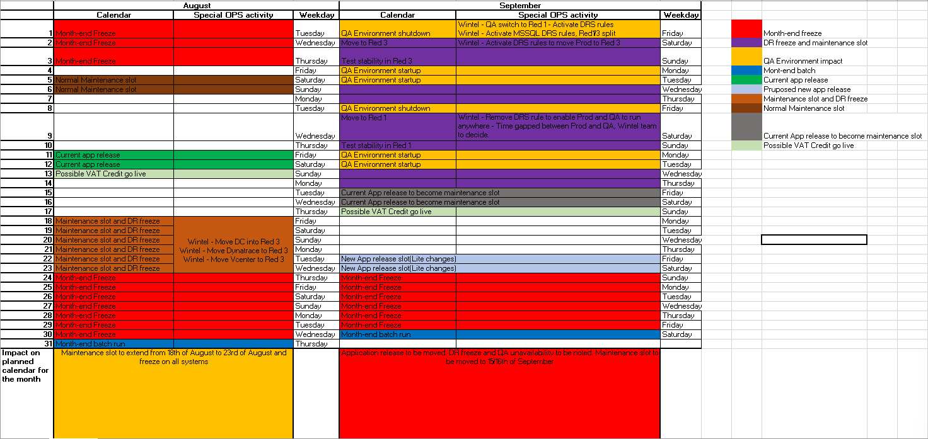

# Distribution

|  |
| --- |
| WesBank IT Exco |
| FML Exco |

Informational:

|  |
| --- |
| FML IT Leadership |